/*NAME :YASH AERON UNIVERSITY ROLL NO: 2025596 SECTION : A
Class Roll No :77*/ Solution1: #include<iostream> #include<string>
using namespace std; int main()
{
float am=0,unit,tam=0; string nm;
cout<<"enter name"<<endl; cin>>nm;
cout<<"enter units"<<endl; cin>>unit;
if(unit<=100)
{
am=unit*0.60;
}
else if(unit<=300)
{
am=100*0.60+(unit-100)*0.80;
}
else
{
am=100*0.60 + 200*0.80+(unit-300)*0.90;
}
if(am<50)
{
am=50;
}
if(am>300)
{
am=am+am*0.15;

}

cout<<"Name of user: "<<nm<<endl; cout<<" Units consumed: "<<unit<<endl; cout<<"total bill: "<<am<<endl;
}

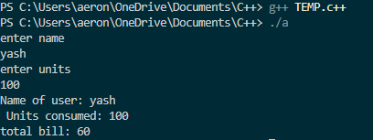

/*NAME :YASH AERON UNIVERSITY ROLL NO: 2025596 SECTION : A
Class Roll No :77*/ Solution2 : #include<iostream> #include<string>
using namespace std; int main()
{
string str; char ch;
cout<<"Enter string"<<endl; getline(cin,str);
cout<<"Enter character to be removed"<<endl; cin>>ch;
int l=str.length(); for(int i=0;i<l;i++)
{
if(str[i]==ch)
{
for(int j=i;j<l;j++)
{
str[j]=str[j+1];
}
l--;
i--;
}}
cout<<str;}

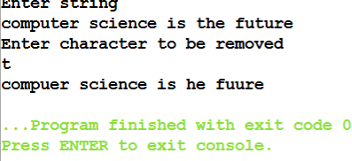

/*NAME :YASH AERON UNIVERSITY ROLL NO: 2025596 SECTION : A
Class Roll No : 77*/ Solution3 : #include<iostream> #include<string>
using namespace std; int main()
{
string str; char ch; int l,f=0;
cout<<"Enter string"<<endl; getline(cin,str); l=str.length();
for(int i=0;i<l;i++)
{
f=0;
for(int j=0;j<l;j++)
{
if(str[j]==str[i]&&i!=j)
{
f=1;
break;
}
}
if(f==0)
{
cout<<str[i];
}
}
}

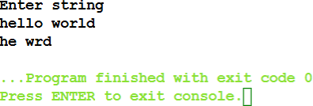

/*NAME :YASH AERON UNIVERSITY ROLL NO: 2025596 SECTION : A
Class Roll No : 77*/

Solution 5: #include<iostream> #include<string> using namespace std; class student{
int roll; string name; public:
void setdetail(string nm,int rn)
{
roll=rn; name=nm;
}
void display()
{
cout<<"name: "<<name<<endl; cout<<"roll no: "<<roll<<endl;
}
};
int main()
{
student s1; s1.setdetail("Yash ", 1); s1.display();
}

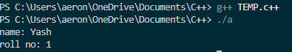

/*NAME :YASH AERON UNIVERSITY ROLL NO: 2025596 SECTION : A
Class Roll No : 77*/

Solution 6: #include<iostream> #include<string> using namespace std; class hotel
{
private: int rno;
string name; float tdata; int nod;
int calc()
{
if(nod*tdata>1000)
{
return 1.05*nod*tdata;
}
else{
return nod*tdata;
}
}
public:
void checking()
{
cout << "Enter Room Number: "; cin >> rno;
cin.ignore();
cout << "Enter Customer Name: "; getline(cin, name);
cout << "Enter Tariff per Day: ";

cin >> tdata;
cout << "Enter Number of Days of Stay: "; cin >> nod;
}
void checkout()
{
cout<<"Room No- "<<rno<<endl; cout<<"Name- "<<name<<endl; cout<<"Tarriff per day- "<<tdata<<endl; cout<<" No of days of stay- "<<nod<<endl; cout<<"Amount- "<<calc();
}
};
int main()
{
hotel h1; h1.checking(); h1.checkout();
}

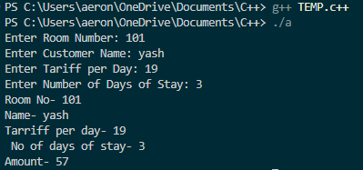

/*NAME :YASH AERON UNIVERSITY ROLL NO: 2025596 SECTION : A
Class Roll No : 77*/

Solution 7: #include<iostream> #include<string> using namespace std; class bankacc
{
string name; int accno; string acct; int balam; int am;
int wam; public:
void setdata()
{
cout<<"Enter name "<<endl; cin>>name;
cout<<"Enter account type(saving/current) "<<endl; cin>>acct;
cout<<"Enter Balance Amount "<<endl; cin>>balam;
cout<<"Enter Account Number "<<endl; cin>>accno;
}
void setam()
{
cout<<"Enter amount to be deposited"<<endl; cin>>am;
balam=balam+am;
}

int withdraw()
{
cout<<"enter amount to be withdrawn"<<endl; cin>>wam;
if(wam>balam)
{
cout<<"Insufficient amount!"<<endl;
}
else{
balam=balam-wam;
}
return balam;
}
void display()
{
cout<<"Name- "<<name<<endl; cout<<"Account Number- "<<accno<<endl; cout<<"Account Type-"<<acct<<endl; cout<<"Remaining amount-"<<balam<<endl;
}

};

int main()
{
bankacc b1; b1.setdata();
b1.setam(); b1.withdraw(); b1.display();
}

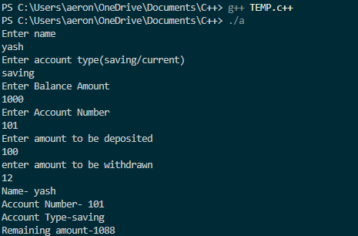

/*NAME :YASH AERON UNIVERSITY ROLL NO: 2025596 SECTION : A
Class Roll No :77*/ Solution 8: #include<iostream>
using namespace std; class student{
int sc[5]; public: void input()
{
int n;
cout<<"Enter marks "<<endl; for(int j=0;j<5;j++)
{
cin>>sc[j];
}
}
int calculatetotalscore()
{
int sum=0,j; for(j=0;j<5;j++)
{
sum=sum+sc[j];
}
return sum;
}
};
int main()
{
student s;
int score,n,res,c=0,i;
cout<<"Enter number of students "; cin>>n;

s.input(); score=s.calculatetotalscore(); for(i=0;i<n-1;i++)
{
s.input(); res=s.calculatetotalscore(); if(res>score)
{
c++;
}
}
cout<<c;
}

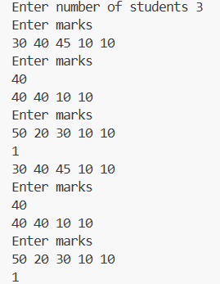

/*NAME :YASH AERON UNIVERSITY ROLL NO: 2025596 SECTION : A
Class Roll No :77*/ Solution 9: #include<iostream>
using namespace std; float calculate(float s)
{
return s*s;
}
float calculate(float l, float b)
{
return l*b;
}
float calculate(double a, double c)
{
return 0.5*a*c;
}
int main()
{
float s,l,b; double a,h;
cout<<"Enter side of sq"<<endl; cin>>s;
cout<<"Area of sq "<<calculate(s)<<endl; cout<<"Enter side of rectangle "<<endl; cin>>l>>b;
cout<<"Area of rectangle "<<calculate(l,b)<<endl; cout<<"Enter height and base of rectangle"<<endl; cin>>h>>a;
cout<<"Area of triangle "<<calculate(a,h);
}

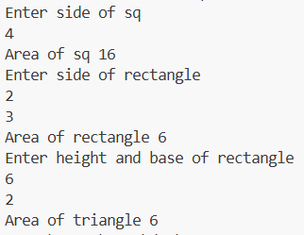

/*NAME :YASH AERON UNIVERSITY ROLL NO: 2025596 SECTION : A
Class Roll No : 77*/ Solution 10:
#include <iostream> #include <string> using namespace std;

class Invoice { private:
string partNumber; string partDescription; int quantity;
double pricePerItem; public:
Invoice(string partNum, string partDesc, int qty, double price) { partNumber = partNum;
partDescription = partDesc; setQuantity(qty); setPricePerItem(price);
}
void setPartNumber(string partNum) { partNumber = partNum;
}
void setPartDescription(string partDesc) { partDescription = partDesc;
}
void setQuantity(int qty) { if (qty > 0)
quantity = qty; else
quantity = 0;
}
void setPricePerItem(double price) {

if (price > 0.0) pricePerItem = price;
else
pricePerItem = 0.0;
}
string getPartNumber() const { return partNumber;
}
string getPartDescription() const { return partDescription;
}
int getQuantity() const { return quantity;
}
double getPricePerItem() const { return pricePerItem;
}
double getInvoiceAmount() const { return quantity * pricePerItem;
}
};
int main() {
Invoice item1("A101", "Hammer", 5, 12.99);
Invoice item2("B202", "Screwdriver", -3, 7.50);
Invoice item3("C303", "Drill", 2, -45.0); cout << "Invoice 1:" << endl;
cout << "Part Number: " << item1.getPartNumber() << endl; cout << "Description: " << item1.getPartDescription() << endl; cout << "Quantity: " << item1.getQuantity() << endl;
cout << "Price per Item: Rs" << item1.getPricePerItem() << endl;
cout << "Total Amount: Rs" << item1.getInvoiceAmount() << endl << endl; cout << "Invoice 2:" << endl;
cout << "Part Number: " << item2.getPartNumber() << endl; cout << "Description: " << item2.getPartDescription() << endl; cout << "Quantity: " << item2.getQuantity() << endl;

cout << "Price per Item: Rs" << item2.getPricePerItem() << endl;
cout << "Total Amount: Rs" << item2.getInvoiceAmount() << endl << endl; cout << "Invoice 3:" << endl;
cout << "Part Number: " << item3.getPartNumber() << endl; cout << "Description: " << item3.getPartDescription() << endl; cout << "Quantity: " << item3.getQuantity() << endl;
cout << "Price per Item: Rs" << item3.getPricePerItem() << endl; cout << "Total Amount: Rs" << item3.getInvoiceAmount() << endl;
}

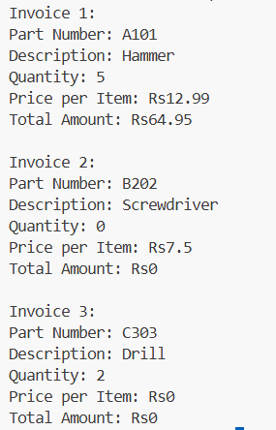

/*NAME :YASH AERON UNIVERSITY ROLL NO: 2025596 SECTION : A
Class Roll No : 77*/ Solution 11:
#include <iostream> #include <string> using namespace std; class tollbooth {
unsigned int carn; double am;
public:
tollbooth() { carn = 0;
am = 0;
}
void payingcar() { carn++;
am = am + 0.5;
}
void nonpayingcar() { carn++;
}
void display() {
cout << "Total cars: " << carn << endl; cout << "Total cash: " << am << endl;
}
};
int main() { tollbooth t1; char ch;

cout << "Press 'p' for paying car" << endl; cout << "Press 'n' for non-paying car" << endl;
cout << "Press 'e' to display totals and exit" << endl;

while (true) {
cout << "\nEnter your choice: "; cin >> ch;
if (ch == 'e' || ch == 'E') { break;
}
else if (ch == 'p' || ch == 'P') { t1.payingcar();
cout << "Paying car recorded." << endl;
}
else if (ch == 'n' || ch == 'N') { t1.nonpayingcar();
cout << "Non-paying car recorded." << endl;
}
else {
cout << "Invalid key! Please press p, n, or e." << endl;
}
}
t1.display(); return 0;
}

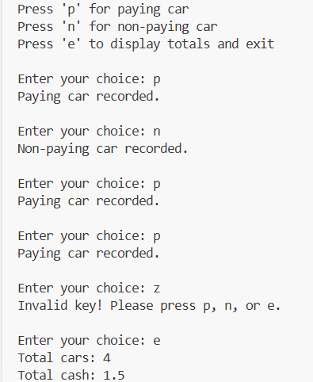

/*NAME :YASH AERON UNIVERSITY ROLL NO: 2025596 SECTION : A
Class Roll No : 77*/ Solution 12:
#include <iostream> using namespace std; class Time {
int hours, minutes, seconds; public:
Time() {
hours = minutes = seconds = 0;
}
Time(int h, int m, int s) { hours = h;
minutes = m; seconds = s;
}
void display() {
cout << (hours < 10 ? "0" : "") << hours << ":"
<< (minutes < 10 ? "0" : "") << minutes << ":"
<< (seconds < 10 ? "0" : "") << seconds << endl;
}
void add(Time t1, Time t2) {
seconds = t1.seconds + t2.seconds;
minutes = t1.minutes + t2.minutes + (seconds / 60); hours = t1.hours + t2.hours + (minutes / 60); seconds %= 60;
minutes %= 60;
hours %= 24;
}
};
int main() {
Time t1(11, 59, 59);
Time t2(2, 5, 10);

Time t3; t3.add(t1, t2);
cout << "First time: "; t1.display();
cout << "Second time: "; t2.display();
cout << "Added time: "; t3.display();
}

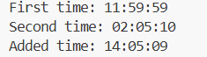

/*NAME :YASH AERON UNIVERSITY ROLL NO: 2025596 SECTION : A
Class Roll No : 77*/ Solution 13:
#include <iostream> using namespace std; class SavingsAccount { private:
double savingsBalance;
static double annualInterestRate; public:
SavingsAccount(double balance) { savingsBalance = balance;
}
void calculateMonthlyInterest() {
double monthlyInterest = (savingsBalance * annualInterestRate) / 12.0; savingsBalance += monthlyInterest;
}
static void modifyInterestRate(double newRate) { annualInterestRate = newRate;
}
void displayBalance() const {
cout << "Rs " << savingsBalance << endl;
}
};
double SavingsAccount::annualInterestRate = 0.0; int main() {
SavingsAccount saver1(2000.00); SavingsAccount saver2(3000.00); SavingsAccount::modifyInterestRate(0.04); saver1.calculateMonthlyInterest(); saver2.calculateMonthlyInterest();
cout << "Balances after 4% interest for one month:\n"; cout << "Saver 1: "; saver1.displayBalance();

cout << "Saver 2: "; saver2.displayBalance(); saver1.calculateMonthlyInterest(); saver2.calculateMonthlyInterest();
cout << "\nBalances after 5% interest for next month:\n"; cout << "Saver 1: "; saver1.displayBalance();
cout << "Saver 2: "; saver2.displayBalance();
}

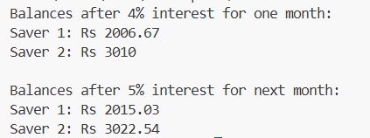

/*NAME :YASH AERON UNIVERSITY ROLL NO: 2025596 SECTION : A
Class Roll No : 77*/ Solution 14: #include<iostream>
using namespace std; class complex{
int a,b; public: complex()
{

}
complex(int a,int b)
{
this->a=a; this->b=b;
}
void display()
{
cout<<a<<"+"<<b<<"i"<<endl;
}

complex add (complex &o)
{
complex temp; temp.a=a+o.a; temp.b=b+o.b; return temp;
}
complex subtract(complex&s)
{
complex temp; temp.a=a-s.a;

temp.b=b-s.b; return temp;
}
int equal(complex&e)
{
return (a==e.a&&b==e.b);
}
};
int main()
{
complex c1(30,40),c2(10,20),c3; c3=c1.add(c2);
c3.display(); c3=c1.subtract(c2); c3.display();
if(c1.equal(c2))
{
cout<<"Complex numbers are equal";
}
else{
cout<<"Complex Numbers are not equal";
}
}

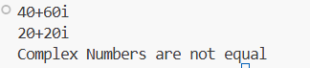

/*NAME :YASH AERON UNIVERSITY ROLL NO: 2025596 SECTION : A
Class Roll No : 77*/ Solution 15: #include<iostream>
using namespace std; class test
{
int a; public: test()
{

}
test(int a)
{
this->a=a;
}
void display()
{
cout<<a<<endl;
}
test operator -()
{
test temp; temp.a=-a; return temp;
}
test operator ++()
{
test temp; temp.a=++a; return temp;
}

test operator ++(int)
{
test temp; temp.a=a++; return temp;
}
test operator --()
{
test temp; temp.a=--a; return temp;
}
test operator --(int)
{
test temp; temp.a=a--; return temp;
}
};
int main()
{
test ob1(10),ob2; ob2=-ob1;
cout<<"Unary -"<<endl; ob2.display(); ob2=++ob1;
cout<<"Preincrement"<<endl; ob2.display();
ob2=ob1++; cout<<"Postincrement"<<endl; ob1.display();
ob2=--ob1; cout<<"Predecrement"<<endl; ob2.display();
ob2=ob1--;

cout<<"Postdecrement"<<endl; ob1.display();
}

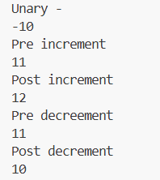

/*NAME :YASH AERON UNIVERSITY ROLL NO: 2025596 SECTION : A
Class Roll No : 77*/ Solution 16: #include<iostream>
using namespace std; class test
{
int a; public: test()
{

}
test(int a)
{
this->a=a;
}
void display()
{
cout<<a<<endl;
}
friend test operator -(test&); friend test operator ++(test&); friend test operator ++(test&,int); friend test operator --(test&); friend test operator --(test&,int);

};
test operator -(test&o)
{
test temp; temp.a=-o.a; return temp;

}
test operator ++(test&o)
{
test temp; temp.a=++o.a; return temp;
}
test operator ++(test&o,int)
{
test temp; temp.a=o.a++; return temp;
}
test operator --(test&o)
{
test temp; temp.a=--o.a; return temp;
}
test operator --(test&o,int)
{
test temp; temp.a=o.a--; return temp;
}
int main()
{
test ob1(10),ob2; ob2=-ob1;
cout<<"Unary -"<<endl; ob2.display(); ob2=++ob1;
cout<<"Preincrement"<<endl; ob2.display();
ob2=ob1++;

cout<<"Postincrement"<<endl; ob1.display();
ob2=--ob1; cout<<"Predecrement"<<endl; ob2.display();
ob2=ob1--; cout<<"Postdecrement"<<endl; ob1.display();
}

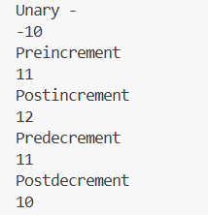

/*NAME :YASH AERON UNIVERSITY ROLL NO: 2025596 SECTION : A
Class Roll No : 77*/ Solution 17:
#include <iostream> using namespace std; class Base {
private:
int priv; protected: int prot;
public:
int pub;
Base() {
priv = 1;
prot = 2;
pub = 3;
}
void showBase() {
cout << "Base private: " << priv << endl; cout << "Base protected: " << prot << endl; cout << "Base public: " << pub << endl;
}
};
class DerivedPublic : public Base { public:
void show() {
cout << "DerivedPublic: prot = " << prot << ", pub = " << pub << endl;
}
};
class DerivedProtected : protected Base { public:
void show() {
cout << "DerivedProtected: prot = " << prot << ", pub = " << pub << endl;

}
};
class DerivedPrivate : private Base { public:
void show() {
cout << "Derivedprivate: prot = " << prot << ", pub = " << pub << endl;
}
};
int main() { DerivedPublic dp; dp.show();
cout << "Accessing public member from main (DerivedPublic): " << dp.pub << endl; DerivedProtected dprot;
dprot.show(); DerivedPrivate dpriv; dpriv.show();
}

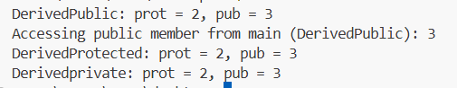

/*NAME :YASH AERON UNIVERSITY ROLL NO: 2025596 SECTION : A
Class Roll No : 77*/ Solution 18:
#include <iostream> using namespace std; class A {
protected: int callA;
public:
A() { callA = 0; } void func(int &val) {
val *= 2; callA++;
}
int getA() { return callA; }
};

class B { protected:
int callB; public:
B() { callB = 0; } void func(int &val) {
val *= 3; callB++;
}
int getB() { return callB; }
};
class C { protected:
int callC; public:
C() { callC = 0; }

void func(int &val) { val *= 5;
callC++;
}
int getC() { return callC; }
};
class D : public A, public B, public C { int val;
public:
D() { val = 1; }

void update_val(int new_val) { while (new_val % 2 == 0) {
A::func(val); new_val /= 2;
}
while (new_val % 3 == 0) { B::func(val);
new_val /= 3;
}
while (new_val % 5 == 0) { C::func(val);
new_val /= 5;
}
}

void display() {
cout << "A's func called " << getA() << " times" << endl; cout << "B's func called " << getB() << " times" << endl; cout << "C's func called " << getC() << " times" << endl; cout << "Value of D's val is " << val << endl;
}
};

int main() { D d;
int new_val = 30; d.update_val(new_val); d.display();
return 0;
}

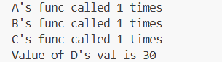

/*NAME :YASH AERON UNIVERSITY ROLL NO: 2025596 SECTION : A
Class Roll No : 77*/ Solution 19:

#include <iostream> #include <string> using namespace std; class Student { protected:
int age; string name;
string enroll_no; float marks;
public:
void getStudentData() {
cout << "Enter Student Name: "; cin >> name;
cout << "Enter Student Age: "; cin >> age;
cout << "Enter Enrollment No: "; cin >> enroll_no;
cout << "Enter Marks: "; cin >> marks;
}
void display() {
cout << "\n--- Student Details ---" << endl; cout << "Name: " << name << endl;
cout << "Age: " << age << endl;
cout << "Enrollment No: " << enroll_no << endl; cout << "Marks: " << marks << endl;
}
};
class Faculty {

protected:
string facultyName; string facultyCode; float salary;
string deptt; int age;
int experience; string gender;
public:
void getFacultyData() {
cout << "\nEnter Faculty Name: "; cin >> facultyName;
cout << "Enter Faculty Age: "; cin >> age;
cout << "Enter Faculty Code: "; cin >> facultyCode;
cout << "Enter Department: "; cin >> deptt;
cout << "Enter Salary: "; cin >> salary;
cout << "Enter Experience (in years): "; cin >> experience;
cout << "Enter Gender: "; cin >> gender;
}
void display() {
cout << "\n--- Faculty Details ---" << endl; cout << "Name: " << facultyName << endl; cout << "Age: " << age << endl;
cout << "Code: " << facultyCode << endl; cout << "Department: " << deptt << endl; cout << "Salary: " << salary << endl;
cout << "Experience: " << experience << " years" << endl; cout << "Gender: " << gender << endl;
}

};
class Person : public Student, public Faculty { public:
void showDetails() {
// Resolve ambiguity using scope resolution operator Student::display();
Faculty::display();
}
};
int main() { Person p;
cout << "Enter Student Information:\n"; p.getStudentData();
cout << "\nEnter Faculty Information:\n"; p.getFacultyData();
cout << "\nDisplaying Information from both Base Classes:\n"; p.showDetails();
return 0;
}

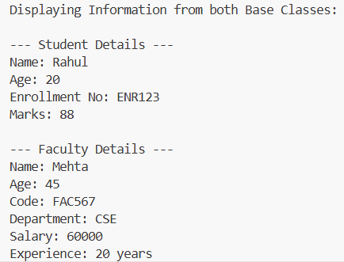

/*NAME :YASH AERON UNIVERSITY ROLL NO: 2025596 SECTION : A
Class Roll No : 77*/ Solution 20:
#include <iostream> #include <string> using namespace std; class Person { public:
string name; int age;
Person(string n, int a) : name(n), age(a) {} void displayPerson() {
cout << "Name: " << name << ", Age: " << age << endl;
}
};
class Student : virtual public Person { public:
int studentID;
Student(string n, int a, int id) : Person(n, a), studentID(id) {} void displayStudent() {
cout << "Student ID: " << studentID << endl;
}
};
class Faculty : virtual public Person { public:
int facultyID;
Faculty(string n, int a, int id) : Person(n, a), facultyID(id) {} void displayFaculty() {
cout << "Faculty ID: " << facultyID << endl;
}
};
class TeachingAssistant : public Student, public Faculty { public:

TeachingAssistant(string n, int a, int sid, int fid): Person(n, a), Student(n, a, sid), Faculty(n, a, fid) {} void display() {
cout << "--- Teaching Assistant Details ---" << endl; displayPerson();
displayStudent(); displayFaculty();
}
};
int main() {
TeachingAssistant ta("Alice", 25, 101, 501); ta.display();
return 0;
}

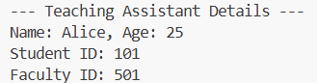

/*NAME :YASH AERON UNIVERSITY ROLL NO: 2025596 SECTION : A
Class Roll No : 77*/ Solution 21:
#include <iostream> using namespace std; class Shape { protected:
double x, y; public:
void get_data() {
cout << "Enter two dimensions: "; cin >> x >> y;
}
virtual void display_area() {
cout << "This function should be overridden in derived classes." << endl;
}
};
class Rectangle : public Shape { public:
void display_area() override { double area = x * y;
cout << "Area of Rectangle = " << area << endl;
}
};
class Triangle : public Shape { public:
void display_area() override { double area = 0.5 * x * y;
cout << "Area of Triangle = " << area << endl;
}
};
int main() {
Shape* shapePtr;

Rectangle rect; Triangle tri;

int choice;
cout << "Choose shape:\n1. Rectangle\n2. Triangle\nEnter choice: "; cin >> choice;

if (choice == 1) { shapePtr = &rect;
} else if (choice == 2) { shapePtr = &tri;
} else {
cout << "Invalid choice." << endl; return 0;
}
shapePtr->get_data(); shapePtr->display_area();

return 0;
}

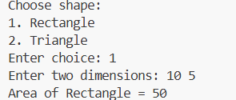

/*NAME :YASH AERON UNIVERSITY ROLL NO: 2025596 SECTION : A
Class Roll No : 77*/ Solution 22:
#include <iostream> #include <cmath> using namespace std; class Shape {
public:
virtual void get_data() = 0;
virtual void display_volume() = 0; virtual ~Shape() {}
};
class Cone : public Shape { double r, h;
public:
void get_data() override {
cout << "\nEnter radius of cone: "; cin >> r;
cout << "Enter height of cone: "; cin >> h;
}
void display_volume() override {
double volume = (M_PI * r * r * h) / 3.0;
cout << "Volume of Cone = " << volume << endl;
}
};
class Cylinder : public Shape { double r, h;
public:
void get_data() override {
cout << "\nEnter radius of cylinder: "; cin >> r;
cout << "Enter height of cylinder: ";

cin >> h;
}
void display_volume() override { double volume = M_PI * r * r * h;
cout << "Volume of Cylinder = " << volume << endl;
}
};
class Hemisphere : public Shape { double r;
public:
void get_data() override {
cout << "\nEnter radius of hemisphere: "; cin >> r;
}
void display_volume() override {
double volume = (2.0 / 3.0) * M_PI * pow(r, 3);
cout << "Volume of Hemisphere = " << volume << endl;
}
};
int main() {
Shape* shape = nullptr; Cone cone;
Cylinder cylinder; Hemisphere hemisphere; int choice;
do {
cout << "\nSelect shape to find volume:\n";
cout << "1. Cone\n2. Cylinder\n3. Hemisphere\n4. Exit\n"; cout << "Enter choice: ";
cin >> choice; switch (choice) {
case 1:
shape = &cone; break;
case 2:

shape = &cylinder; break;
case 3:
shape = &hemisphere; break;
case 4:
cout << "Exiting program.\n"; return 0;
default:
cout << "Invalid choice. Try again.\n"; continue;
}
shape->get_data();
shape->display_volume();

} while (true); return 0;
}

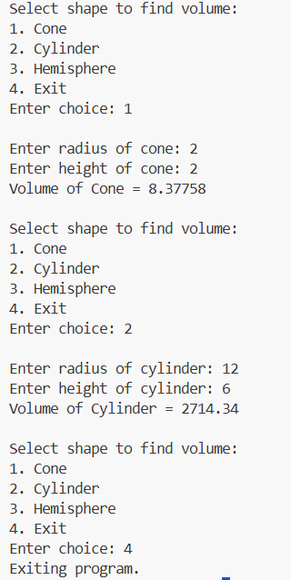

/*NAME :YASH AERON UNIVERSITY ROLL NO: 2025596 SECTION : A
Class Roll No : 77*/ Solution 23:
#include <iostream> using namespace std;
int largest_proper_divisor(int n) { if (n == 0) {
cout << "the largest proper divisor is not defined for n=0" << endl; throw "error";
}
if (n == 1) {
cout << "the largest proper divisor is not defined for n=1" << endl; throw "error";
}
for (int i = n / 2; i >= 1; --i) { if (n % i == 0)
return i;
}
return -1;
}
void process_input(int n) { try {
int result = largest_proper_divisor(n); cout << "result=" << result << endl;
}
catch (const char*) {
}
cout << "returning control flow to the caller" << endl;
}
int main() { int n;
cin >> n; process_input(n);

return 0;
}

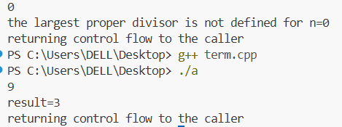

/*NAME :YASH AERON UNIVERSITY ROLL NO: 2025596 SECTION : A
Class Roll No : 77*/ Solution 24:
#include <iostream> using namespace std; template <typename T> class List {
private:
T *arr; int size;
int capacity; void resize() {
capacity *= 2;
T *newArr = new T[capacity]; for (int i = 0; i < size; ++i)
newArr[i] = arr[i]; delete[] arr;
arr = newArr;
}
public:
List(int cap = 5) { capacity = cap; size = 0;
arr = new T[capacity];
}
~List() { delete[] arr;
}
void insert(T value) { if (size == capacity)
resize(); arr[size++] = value;
}

void remove() { if (size == 0) {
cout << "List is empty, nothing to delete." << endl; return;
}
size--;
}
void display() const { if (size == 0) {
cout << "List is empty." << endl; return;
}
cout << "List elements: "; for (int i = 0; i < size; ++i) cout << arr[i] << " ";
cout << endl;
}
};
int main() {
cout << "Choose data type for list:\n"; cout << "1. int\n2. float\n3. char\n"; int choice;
cin >> choice;
if (choice == 1) { List<int> intList; intList.insert(10); intList.insert(20); intList.insert(30); intList.display(); intList.remove(); intList.display();
}
else if (choice == 2) { List<float> floatList; floatList.insert(1.1);

floatList.insert(2.2); floatList.insert(3.3); floatList.display(); floatList.remove(); floatList.display();
}
else if (choice == 3) { List<char> charList; charList.insert('A'); charList.insert('B'); charList.insert('C'); charList.display(); charList.remove(); charList.display();
}
else {
cout << "Invalid choice." << endl;
}
return 0;
}

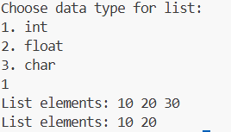

/*NAME :YASH AERON UNIVERSITY ROLL NO: 2025596 SECTION : A
Class Roll No : 77*/ Solution 25:
#include <iostream> #include <list> #include <vector> #include <map> using namespace std;
void demonstrateList() {
cout << "===== Demonstrating std::list =====" << endl; list<int> myList;
myList.push_back(10); myList.push_back(20); myList.push_back(30); myList.push_front(5);
cout << "List after insertion: "; for (int val : myList)
cout << val << " "; cout << endl;
myList.remove(20); // removes all elements equal to 20 cout << "List after removing 20: ";
for (int val : myList) cout << val << " ";
cout << endl; myList.reverse();
cout << "List after reverse: "; for (int val : myList)
cout << val << " "; cout << endl; myList.sort();
cout << "List after sort: "; for (int val : myList)
cout << val << " ";

cout << endl; cout << endl;
}
void demonstrateVector() {
cout << "===== Demonstrating std::vector =====" << endl; vector<int> myVector;
myVector.push_back(1); myVector.push_back(2); myVector.push_back(3);
cout << "Vector after insertion: ";
for (size_t i = 0; i < myVector.size(); ++i) cout << myVector[i] << " ";
cout << endl; myVector.insert(myVector.begin() + 1, 99); cout << "Vector after inserting 99 at index 1: "; for (size_t i = 0; i < myVector.size(); ++i)
cout << myVector[i] << " "; cout << endl;
myVector.erase(myVector.begin() + 2);
cout << "Vector after erasing element at index 2: "; for (size_t i = 0; i < myVector.size(); ++i)
cout << myVector[i] << " "; cout << endl; myVector.pop_back();
cout << "Vector after pop_back(): ";
for (size_t i = 0; i < myVector.size(); ++i) cout << myVector[i] << " ";
cout << endl;
cout << "Front element: " << myVector.front() << endl; cout << "Back element: " << myVector.back() << endl; cout << endl;
}
void demonstrateMap() {
cout << "===== Demonstrating std::map =====" << endl; map<int, string> myMap;

myMap[1] = "Apple"; myMap[2] = "Banana"; myMap[3] = "Cherry";
myMap.insert(pair<int, string>(4, "Dates")); cout << "Map elements (key -> value):" << endl;
for (map<int, string>::iterator it = myMap.begin(); it != myMap.end(); ++it) cout << it->first << " -> " << it->second << endl;
int key = 2;
map<int, string>::iterator it = myMap.find(key); if (it != myMap.end())
cout << "Found key " << key << " with value: " << it->second << endl; else
cout << "Key " << key << " not found." << endl; myMap.erase(1);
cout << "Map after erasing key 1:" << endl;
for (auto itr = myMap.begin(); itr != myMap.end(); ++itr) cout << itr->first << " -> " << itr->second << endl;
cout << "Map size: " << myMap.size() << endl; myMap.clear();
cout << "Map cleared. Is empty? " << (myMap.empty() ? "Yes" : "No") << endl; cout << endl;
}
int main() { demonstrateList(); demonstrateVector(); demonstrateMap(); return 0;
}

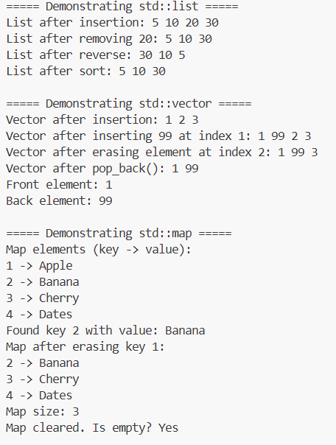

/*NAME :YASH AERON UNIVERSITY ROLL NO: 2025596 SECTION : A
Class Roll No : 77*/ Solution 26:
#include <iostream> #include <vector> using namespace std; int main() {
int N;
cin >> N; vector<int> v(N);
for (int i = 0; i < N; ++i) cin >> v[i];
int x;
cin >> x; int a, b;
cin >> a >> b; v.erase(v.begin() + (x - 1));
v.erase(v.begin() + (a - 1), v.begin() + (b - 1)); cout << v.size() << endl;
for (int i = 0; i < v.size(); ++i) cout << v[i] << " ";
cout << endl; return 0;
}

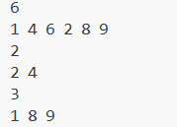

/*NAME :YASH AERON UNIVERSITY ROLL NO: 2025596 SECTION : A
Class Roll No : 77*/ Solution 4:
#include <iostream> #include <climits> using namespace std; int main() {
int n;
cin >> n;
long long arr[100000]; for (int i = 0; i < n; ++i)
cin >> arr[i];
long long prefix[100001]; prefix[0] = 0;
for (int i = 1; i <= n; ++i)
prefix[i] = prefix[i - 1] + arr[i - 1]; long long max_sum = LLONG_MIN; for (int i = 0; i < n; ++i) {
long long sum = 0; int k = 1;
int start = i + 1;
int end = start + k - 1; while (end <= n) {
sum += prefix[end] - prefix[start - 1]; k++;
start = end + 1; end = start + k - 1;
}
if (sum > max_sum) max_sum = sum;
}
cout << max_sum << endl;

return 0;
}

